About Us

CIDAK AUTO PARTS LTD is an independent leading company in United Kingdom and Europe, distributing aftermarket automotive spare parts to wholesaler and distributors worldwide. The head office located in Ascot (35 minutes from Central London) with 3PL warehouse facility in UK, Slovenia and Bulgaria.

“We aim is to offer CIDAK branded aftermarket parts at very competitive prices and premium quality. We aim to build up a strong and long-term partnership with our customers. This partnership approach allows us and our partners to continue grow together and enjoy commercial benefit for long term”.

What we offer….

Premium Quality
Competitive Price
Extended Range
High Stock Availability
Excellent Customer Service
Excellent Technical Support

Head Office: -
CIDAK AUTO PARTS LTD
Craven Lodge, Coronation Road
Ascot HP22 5EN
United Kingdom.

UK Office:-
CIDAK AUTO PARTS LTD
Venture House, Downshire Way,
Arlington Square, Bracknell RG12 1WA
United Kingdom

Overseas Logistic Centre: -
CIDAK AUTO PARTS LTD
2HM Logistics,
Kidriceva Cesta 92 4220,
Skofja Loka, Slovenia

Overseas Office & Warehouse: -
CIDAK AUTO PARTS LTD
81 Tzar Boris III Blvd,
Entrance V, 6th Floor Studio 1,
SOFIA, 1612,
Bulgaria

Contact
E mail: - harvinder@cidakautoparts.com
Mob:- +44 7931522602

Directors

Harvinder Handa, Commercial Director

Dr Sukh Handa, Operational Director

Products

Brake Pads

The text below must be supported with images as below. Perhaps text can leave and images to right or align them as they look good. I have attached every product leaflet for further input.

When it comes to “Safe & Noise Free Braking” CIDAK brake pad range offers an exclusive product to automotive aftermarket with consist braking performance. The points below demonstrate, CIDAK brake pads high quality features.

- CIDAK brake pads are being designed and produced in high standards manufacturing facilities under strict quality control and standards.

- All CIDAK brake pads are ECE R90 (E-Marked) approved, which confirms that brake pad performance within +/- 15% of original part in term of performance tests.

- CIDAK unique friction material compound blends of raw material to deliver excellent braking performance. Whilst, the “ceramic material” produces premium quality brake pads, a “semi metallic” material also produces a high-quality brake pad to deliver excellent braking results.

- All CIDAK brake pads having RMR (Rubber Metal Rubber) shim, an “anti-noise” shim to reduce the noise level.

- The EPA (United States Environmental Protection Agency) took initiative to reduce Copper content in brake pad to protect the environment, CIDAK brake pads are completely “Copper Free”

- Excellent braking performance has proved that CIDAK brake pads will go long-lasting with consistent performance.

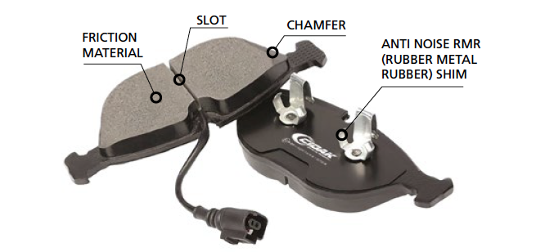

Brake Disc

When it comes to “Excellent Braking” CIDAK brake disc range offers an exclusive product to automotive aftermarket with consist braking performance. The points below demonstrate, CIDAK brake discs high quality features.

- CIDAK brake discs are being designed and produced in high standards manufacturing facilities under strict quality controls.

- High quality standards are maintained whilst selection of raw material, melting iron, casting in a foundry, and machining at CNC (computer numeric controlled) machines.

- All CIDAK brake discs are having unique “silver coating” to protect from corrosion and give a stunning appearance, at the same time easy to fit in a vehicle as it doesn’t need to remove dirt/oil from discs surface.

- All CIDAK brake discs are ECE R90 (E-Marked) approved, which confirms that brake pad performance within +/- 15% of original part in term of performance tests.

Filters

Individual Images of Air, Oil, Fuel, Cabin, Carbon Filter will go along with TEXT.

High quality of filtration is essential for vehicle which needs a high quality of filter media. CIDAK filters are being manufacture with standards close to original part. The range covers Air, Oil, Fuel, Cabin. Carbon Filters.

- All CIDAK filters being manufactures with high quality filter media. These media have capability to deliver excellent filtration results.

- The Air filter is design to have a sufficient pleat to conduct proper filtration and to fit securely in filtration housing.

- The Oil filter is vital component to feed dirt free oil to engine. The range covers metal type and ecological filters. All parts conducted pressure test to demonstrate the efficient filtration.

- The Fuel filters is also a vital component to remove impurities and dirt from fuel and feed clean fuel to engine to avoid damage engine. All parts are designed and manufactured as per high standard to deliver such results.

- The Cabin and Carbon filters are being manufactured with high quality paper media to provide a fresh and clean air to cabin.

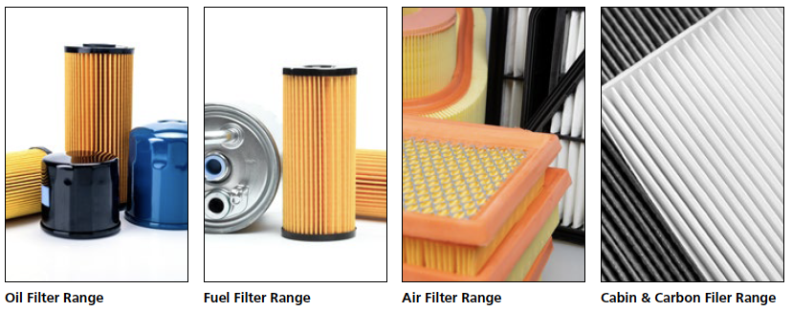

Steering & Suspension

Steering & suspension are key components for vehicle safety. CIDAK steering & suspension manufacturing partners are designing and producing parts with high standard and modern Technology. The range covers Control Arms, Ball Joint, Stabilizer Link, Bushes, Tie rods, Suspension Kits.

- The raw material of all parts being selected as per original manufactures standards and maintain the quality parameters during very manufacturing process.

- The modern production technology has offered a great quality to entire steering & suspension range. This includes CNC machines and robotics.

- All parts being tested at each stage of manufacturing for performance and reliability.

- All parts being painted and performed the salt spray test to avoid corrosion.

Product Range Under Development

Quality

CIDAK brand offers matching OE quality for its entire product range. Delivering, consistent quality is prime objective of CIDAK. The quality map below explains how product quality being monitored at each stage until deliver to our distributors.

Every part number material and manufacturing process set as per high quality standards to deliver excellent performance.

When the product reaches to Cicak’s warehouses, the quality standard monitored to justify its consistency.

The quality is maintained and checked 100 % at every stage of manufacturing process to ensure consistent quality.

Finally, when the product reaches to our distributors, we check further level of quality by physical testing in the vehicles.

T

CIDAK offers 3 years or 60,000 kms no quibble warranty due to high standards of quality level.

